To: Page Gardner, Voter Participation Center
From: Nancy Zdunkewicz and Lauren Goldstein, Change Research
Date: July 9, 2020

Key Findings from Survey of States with Little or No History of VBM

On behalf of the Voter Participation Center, Change Research surveyed 1,497 likely voters in states with limited or no history of voting by mail (Georgia, Kentucky, Michigan, North Carolina, New Hampshire, New Mexico, Nevada, Pennsylvania, South Carolina, Virginia, and Wisconsin) from June 22-24, 2020. While the vast majority of respondents report usually voting in person, consistent with the design of this survey, a considerable number would prefer to vote by mail in November, though the plurality do not know the rules in their state. Voters are more swayed by the health risks of in-person voting than by logistical concerns such as transportation to the polls and securing time off work, and these health-related concerns are particularly pronounced among groups that comprise the Rising American Electorate (18-34 year olds, voters of color, and unmarried women). When it comes to voting by mail, respondents are most compelled by the assurance that coronavirus will not impede their ability to cast their votes, though concerns about voter fraud via mail-in ballots remain a concern, though less prevalent among RAE voters.

Methods of Voting & Information Levels Around Voting By Mail

While fewer than 1 in 10 respondents usually vote by mail, more than a third of respondents would prefer to vote by mail in the upcoming November election. The vast majority (81%) of respondents report their usual method of voting is in person on Election Day, and another 11% vote in person through early voting. Only 6% of respondents vote by mail or absentee ballot. Despite the fact that 92% of respondents usually vote in person, only 64% say they prefer to vote in person in the upcoming November election (54% in person on Election Day, and 10% through early in-person voting), while 36% would prefer to vote by mail or absentee ballot. Among the RAE, preference for voting by mail in the upcoming election is slightly higher, at 40%. Specifically, within the RAE, preference for voting by mail was strongest among unmarried women: 46% report preferring to vote by mail in the November election.

The plurality of respondents (34%) are unsure of the rules in their state for voting by mail. Among RAE respondents, 40% of 18-34 year olds in particular are unsure of the rules in their state. Of voters in states that permit no-excuse absentee voting (GA, MI, NC, PA, VA, and WI), most voters do not know that any voter can request a mail ballot without providing a reason. Respondents in MI and WI have the greatest awareness that their state permits no-excuse absentee voting, at 40% and 32%, respectively. Awareness is lowest among respondents in Virginia, where just 10% correctly identify that in their state, any voter can request a mail ballot without providing a reason. The majority of respondents in SC *57%) and nearly half in VA (49%) are unaware of the current vote-by-mail rules in their states.

In-Person Voting

When it comes to concerns about in-person voting, respondents were not very concerned about the logistical aspects of in-person voting such as lines or making time, but expressed meaningfully more concern about the health risks. Even after the recent news coverage of long lines and wait times at polling places during the primaries, 43% of respondents report this is “not concerning at all”. Similarly, 50% say that the possibility of polling places changing due to coronavirus is “not concerning at all.” Overwhelmingly, respondents reported no concern at all about getting time off work to vote (78% “not concerning at all”) and securing transportation to and from the polls (86% “not concerning at all”).
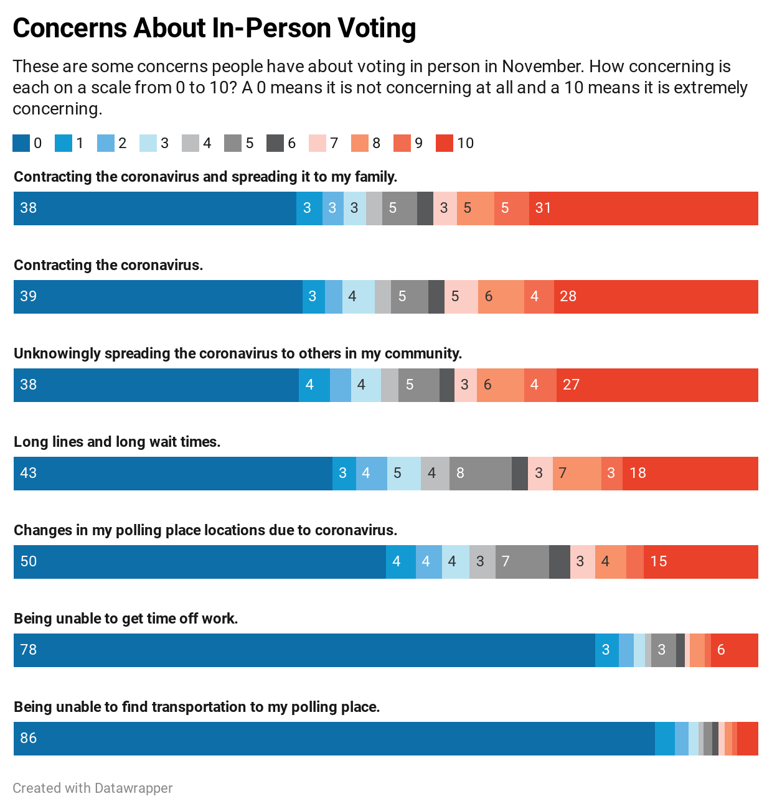

On the matter of health risks, however, respondents expressed more concern. Overall, 31% say the risk of contracting the coronavirus and spreading it to their family is “extremely concerning”, and 27% say unknowingly spreading
the coronavirus to other community members is “extremely concerning.”
Importantly, RAE respondents expressed considerably greater concern about the health risks of voting in person, compared to the overall sample. When it comes to concern about getting coronavirus and spreading it to family members, 30% of respondents in the overall sample rated this as “extremely concerning,” or a 10 out of 10, and 39% rated this possibility at an 8, 9, or 10 out of 10. By comparison:
- 47% of respondents of color rated this as “extremely concerning,” or a 10 out of 10, and 59% rated this possibility at an 8, 9, or 10 out of 10;
- 41% of unmarried women rated this as “extremely concerning,” or a 10 out of 10, and 55% rated this possibility at an 8, 9, or 10 out of 10;
- 38% of 18-34 year olds rated this as “extremely concerning,” or a 10 out of 10, and 51% rated this possibility at an 8, 9, or 10 out of 10.

Similarly, when it comes to concern about unknowingly spreading the coronavirus to other community members, 27% of respondents in the overall sample rated this as “extremely concerning,” or a 10 out of 10, and 37% rated this possibility at an 8, 9, or 10 out of 10. By comparison:
- 42% of respondents of color rated this as “extremely concerning,” or a 10 out of 10, and 56% rated this possibility at an 8, 9, or 10 out of 10;
- 39% of unmarried women rated this as “extremely concerning,” or a 10 out of 10, and 52% rated this possibility at an 8, 9, or 10 out of 10;
- 32% of 18-34 year rated this as “extremely concerning,” or a 10 out of 10, and 45% rated this possibility at an 8, 9, or 10 out of 10.

Voting By Mail
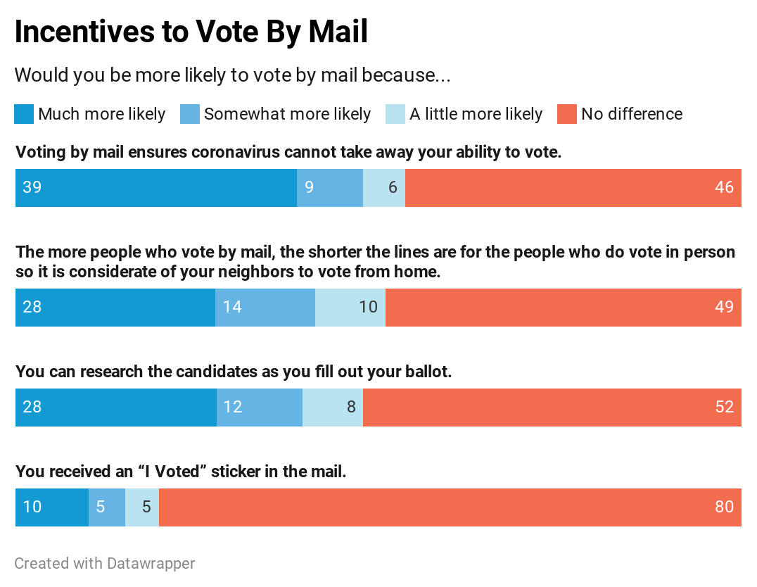 | The most effective incentive to vote by mail emphasizes the fact that coronavirus will not impede voters’ ability to make their voices heard in the election, with 48% reporting this made them more likely to vote by mail and 39% much more likely to vote by mail. The message emphasizing social consideration, and the message emphasizing convenience and ease of completing a ballot, performed equally well, with 28% reporting these made them much more likely to vote by mail.
Again, RAE respondents--particularly unmarried women and voters of color--expressed considerably greater likelihood to vote by mail based on these incentives than the overall sample.
- 52% of unmarried women respondents reported being much more likely to vote by mail because it ensures coronavirus will not prevent them from voting, as did 42% of respondents of color;
- 39% of unmarried women respondents reported being much more likely to vote by mail based on the convenience and ease of researching candidates while filling out their ballot, as did 43% of respondents of color;
- 38% of unmarried women respondents reported being much more likely to vote by mail based on showing consideration to others by voting by mail and shortening lines, as did 43% of respondents of color.

Overall, the incentives to vote in person that we tested were more effective than the incentives to vote by mail. The top reason for voting in person is that it guarantees their voice counts because ballots may not arrive safely through mail: 45% of respondents say that is an extremely convincing reason to cast a vote in person. Similarly, the same proportion think that arguments about voter fraud being more likely with mail-in ballots is an extremely convincing reason to cast a vote in person.

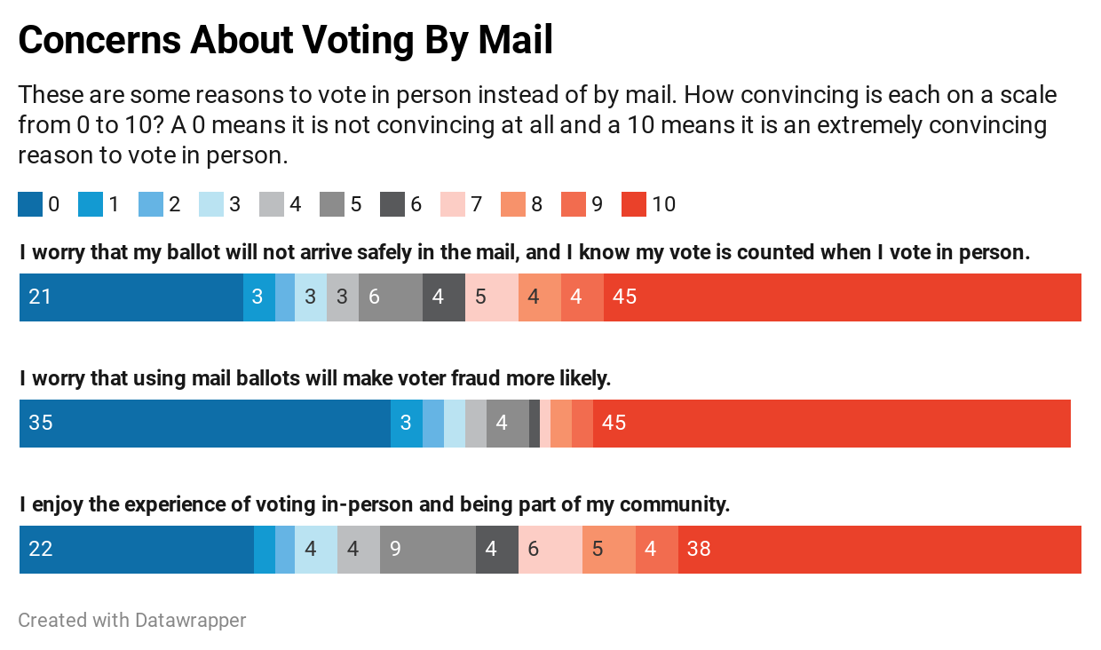

Importantly, however, these reasons to vote in person are less compelling to RAE respondents, particularly when it comes to concerns about voter fraud. Voters of color are 10 points less likely to think that voter fraud rising due to vote by mail is an extremely convincing reason to vote in person than White voters (37% compared to 47%). Similarly, unmarried women are 9 points less likely to think that voter fraud rising due to vote by mail is an extremely convincing reason to vote in person than the sample overall (36% compared to 45%).

Using its Dynamic Online Sampling Engine to attain a sample reflective of the electorate, Change Research polled 1,497 likely voters in states with limited or no history of voting by mail (Georgia, Kentucky, Michigan, North Carolina, New Hampshire, New Mexico, Nevada, Pennsylvania, South Carolina, Virginia, and Wisconsin) from June 22-24, 2020. The margin of error as traditionally calculated is ±2.53% and larger among subgroups. Post-stratification weighting was performed on state, age, gender, race/ethnicity, and education, and 2016 presidential vote.

